Ideation Phase

Define the Problem Statements

Date | 04 August 2026
Project Name | Automated Network Request Management in ServiceNow
Maximum Marks | 2 Marks

Customer Problem Statement Template :
The Automated Network Request Management in ServiceNow project aims to simplify and automate network request handling within an organization. The existing manual process causes delays, repeated follow-ups, and limited visibility.
Using ServiceNow service catalog, workflows, approvals, and notifications, users can submit requests through a self-service portal while the system automatically manages routing, approvals, task assignments, and status updates. This improves efficiency, reduces manual effort, and provides a faster and more transparent request management process.
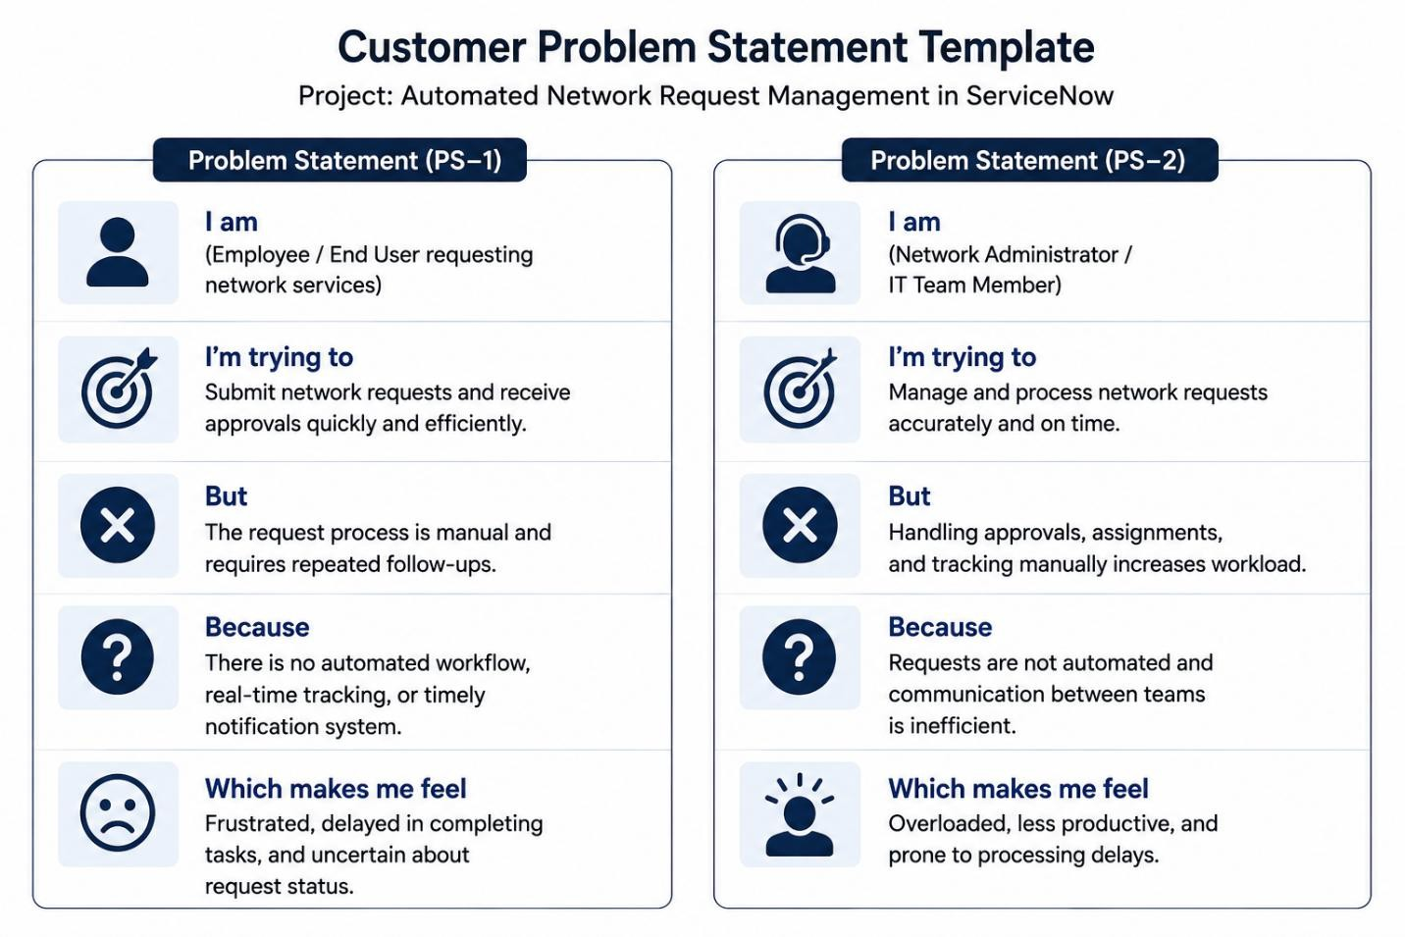

Problem Statement (PS) | I am (Customer) | I’m trying to | But | Because | Which makes me feel
PS-1 | Employee/Customer | Access Network Services | Process is manual | No automated workflow | Frustrated, delayed in completing my tasks, uncertain about request.
PS-2 | Network Admin | Manage network access and services | Handling approvals, assignments manually increases workload | Requests are not automated | Overloaded, less productive.

